Nmap Scan Report + OpenVAS Vulnerability Report

1. **Nmap Scan Report**

Firstly we have to install Nmap in our Operating System.

Open terminal in Kali Linux.

Put command sudo apt install nmap.

* Nmap TCP & UDP SCAN

Nmap -sS: Run a TCP SYN scan, Often called a stealth pr half-open scan.

Run the command for TCP scan sudo nmap -sS 192.168.1.10

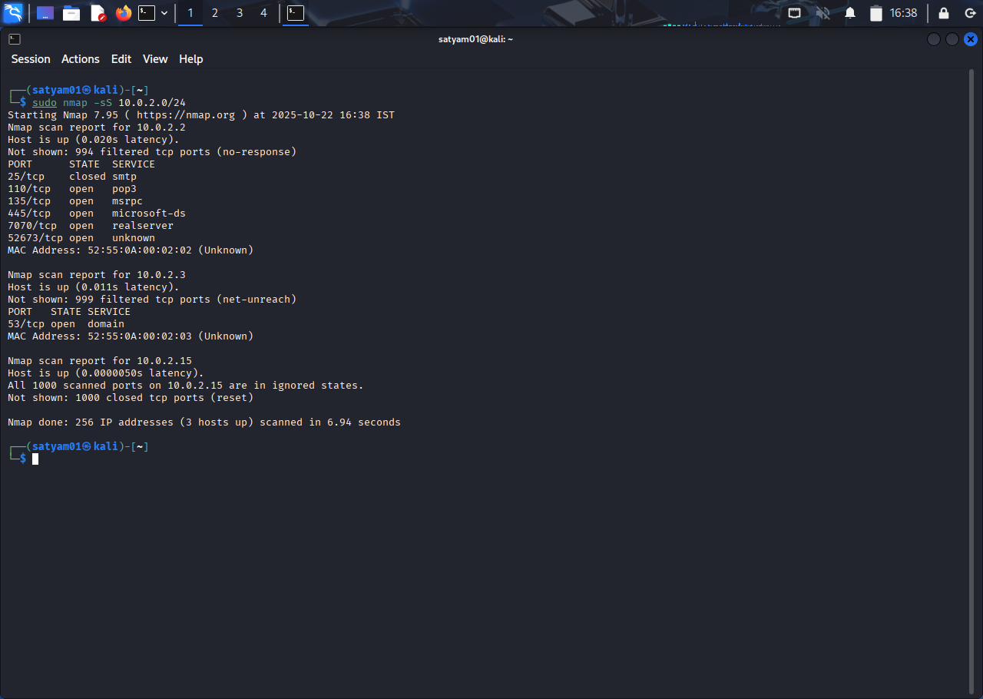

Nmap -sU: It scans **UDP ports** on the target to discover services that use the **User Datagram**

**Protocol (UDP)** instead of TCP.

Run the command for UDP scan sudo nmap -sU 192.168.1.10

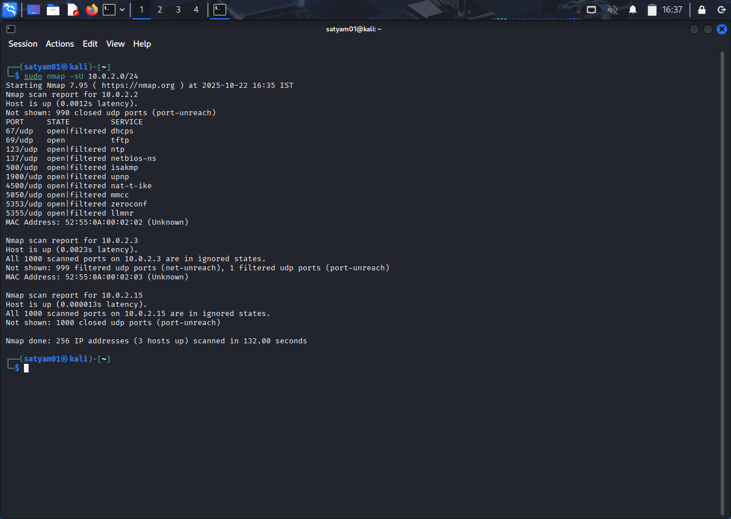

* Service Version Detection.

Nmap -sV: Helps you know exactly **which software and version** are running so you can check

for known vulnerabilities, misconfigurations, or compatibility needs.

Run the command for Service Version Detection sudo nmap -sV 192.168.1.10

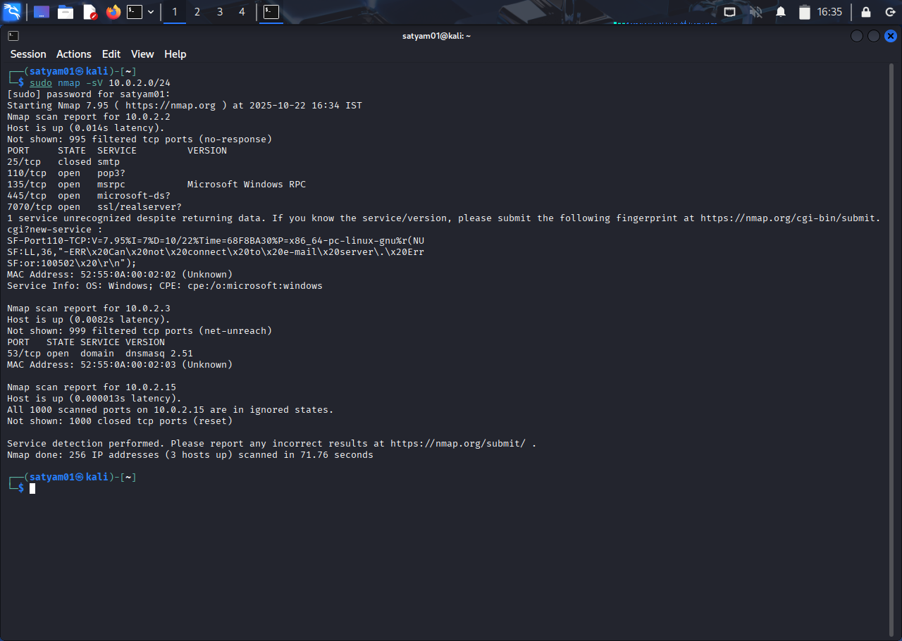

* OS Detection.

Nmap -O: Nmap enables operatingsystemdetection (OS fingerprinting).

Run the command sudo nmap -O 192.168.1.10

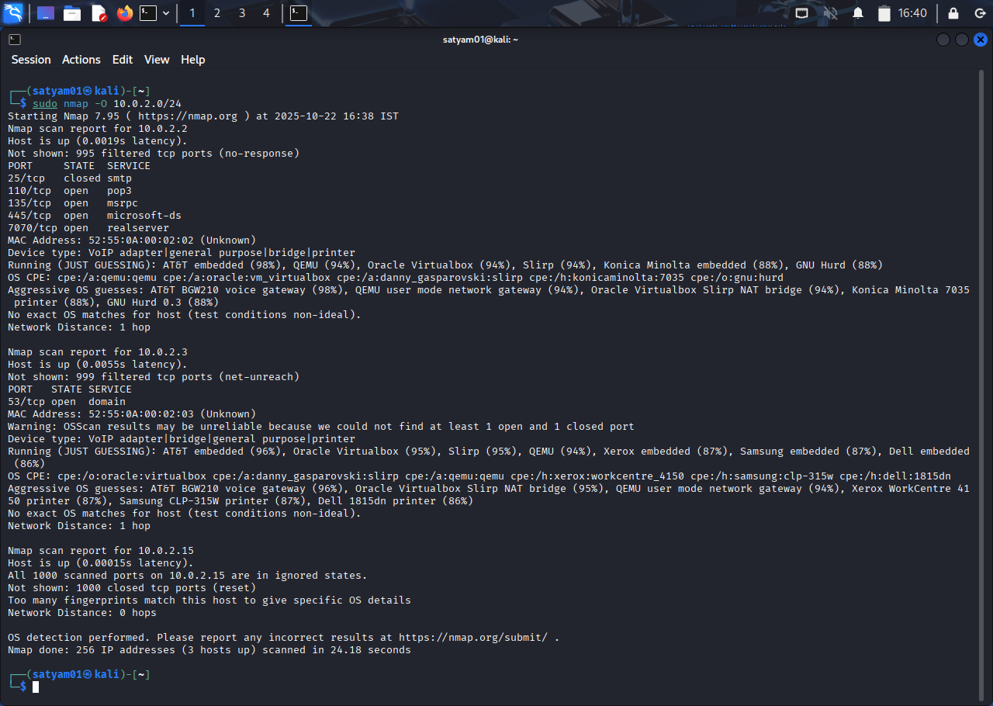

1. **OpenVAS Vulnerability**

To install Openvas in your Operating system.

Open terminal in Kali Linux.

Update system by command sudo apt update

Install OpenVAS by sudo apt install openvas

Then give command sudo gvm-setup

Check the setup by sudo gvm-check-setup (If any error fix it by sudo gvm-fix-and name of your error).

Create User Account by

sudo runuser -u _gvm--gvmd—create-user=admin2 --new-password=password

this command provide an password copy it.

Then provide an command sudo su to open openvas.

Then give a command to start gvm-start.

System will load OpenVAS on your screen,

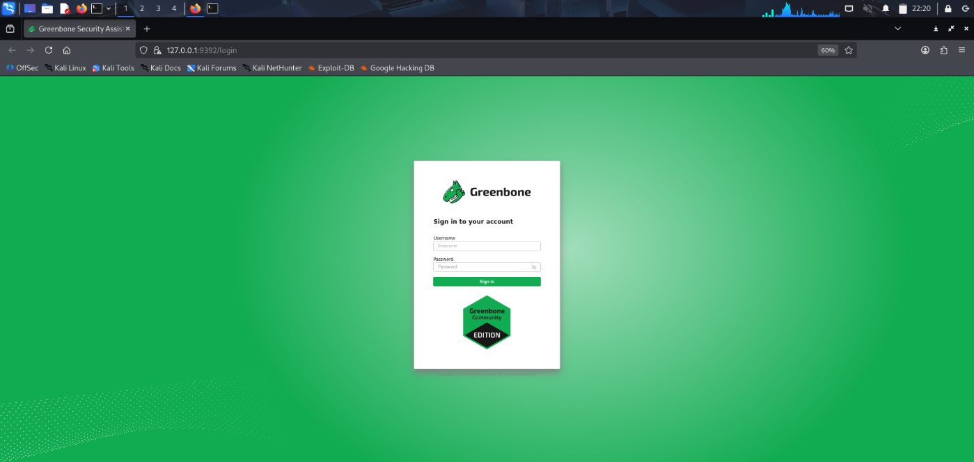

Fill you username and in password paste the password you copied before.

Now you loged in OpenVAS.

Change password for your convenience.

* **OpenVAS Scan Report**

To scan go to Scan Tasks and open Task Wizard,

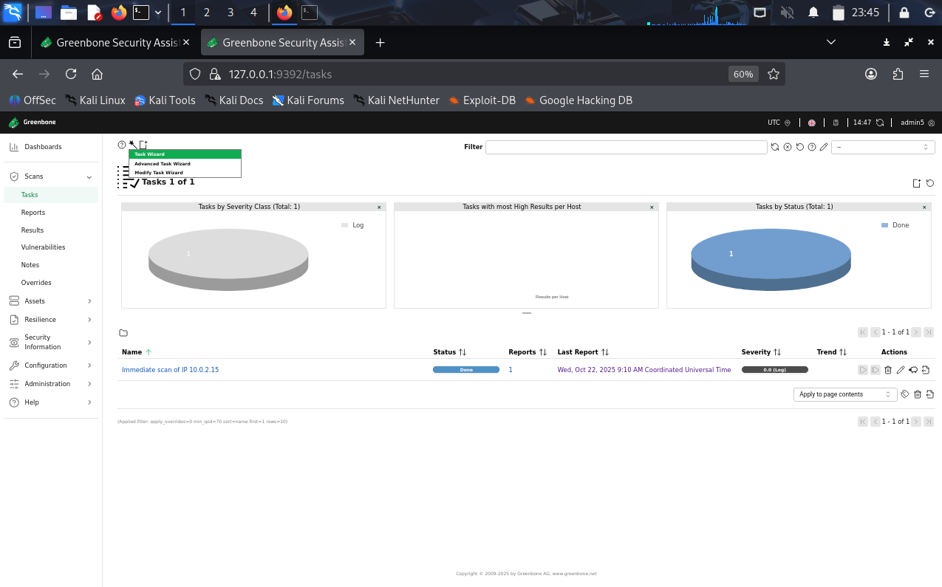

Then put the IP Address of the website or device which you want to scan,

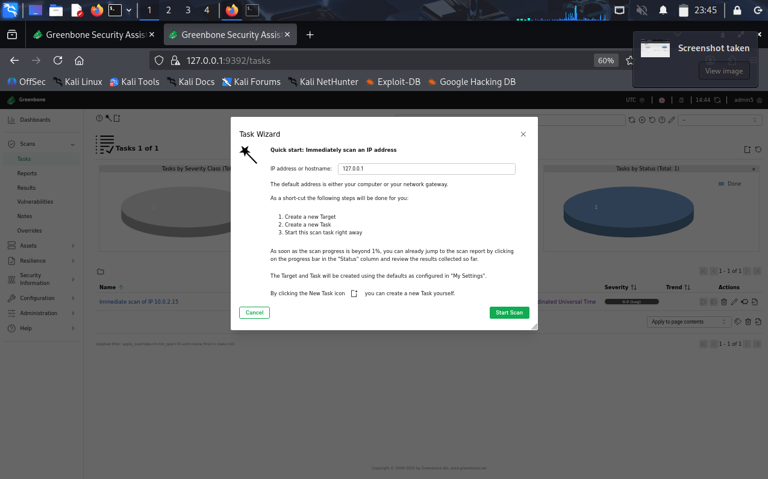

It will Take some time to Scan,

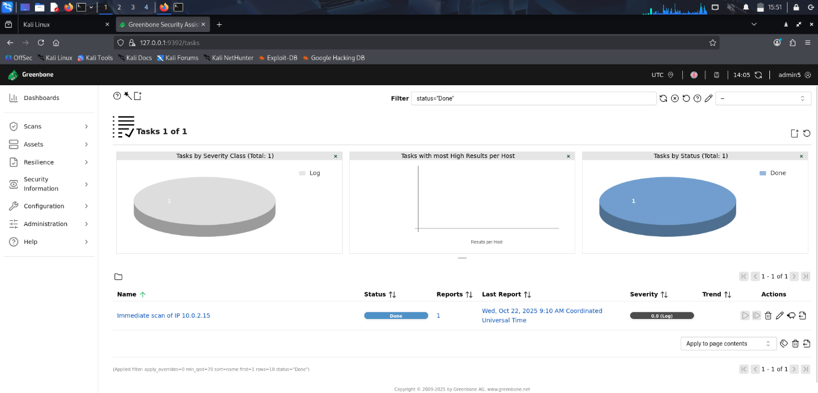

Now you can see the result of your scan.